CSA02 – C PROGRAMMING
ASSIGNMENT 1
TASK 01
Understand the Problem and Identify the Data
Student name: A.K.KISHORE KUMAR
Register number:1913260079
Repository:https://github.com/kishore091008-max/C-PROGRAMMING/upload
Marks: 4 | Course Outcome: CO1

1. Problem Analysis and Design
The program receives a household identifier, category, previous meter reading and current meter reading. It derives consumption, energy charge, fixed charge and total bill. The meter is a 16-bit register with values 0–65535. For a single rollover, consumption is calculated modulo 65536: (current - previous + 65536) % 65536. This formula also returns an ordinary difference when current >= previous.
Inputs: household ID and category identify the account; previous/current readings are required to derive usage. Outputs: units consumed, energy charge, fixed charge and total payable. Tariff thresholds and rates are configuration values that remain constant during one run. The meter readings and units are integral. Monetary values should be integral paise to avoid binary floating-point rounding. Totals may be large when processing district-scale data, so use a sufficiently wide integer type and check bounds.
Correctness rules: consumption must follow the documented rollover rule; energy charge is non-negative; fixed charge is non-negative; total = energy charge + fixed charge; each amount is formatted as rupees and two paise digits. Assumptions: at most one rollover occurs between readings; a reading pair with a decrease is treated as rollover because the source specification gives no separate reset flag; negative text input is invalid; the fixed charge is ₹50 and the tariff slabs are those in the assignment.

2. Pseudocode / Algorithm
READ household ID, category, previous reading, current reading
VALIDATE readings are in 0..65535
units = (current - previous + 65536) % 65536
energy = 0 for first 100 units; ₹2.25 for units 101–200; ₹4.50 above 200
fixed = 5000 paise
total = energy + fixed
PRINT units and all charges as rupees.paise

3. C Source Code
#include <stdio.h>
#include <limits.h>
typedef unsigned short meter_t;
unsigned int consumption(meter_t previous, meter_t current) {
return (unsigned int)((current - previous) & USHRT_MAX);
}
int main(void) {
printf("sizeof(meter_t) = %zu bytes, maximum reading = %u\n",
sizeof(meter_t), (unsigned)USHRT_MAX);
printf("Consumption: %u units\n", consumption(1200, 1530));
printf("Consumption: %u units\n", consumption(65400, 120));
return 0;
}

4. Expected / Reference Result
sizeof(meter_t) = 2 bytes, maximum reading = 65535
Consumption: 330 units
Consumption: 256 units
Captured local compiler/execution evidence is provided in compile_output.txt. Confirm it on your own machine and add a genuine screenshot of your terminal before submission.

5. Alternative Concept and Complexity Analysis
If readings are stored as text such as "01530", each string requires d characters plus a terminator when stored as a C string. Conversion and digit-by-digit validation take O(d) time per reading; integer comparison and arithmetic are O(1) for a fixed-width integer. For N readings, string conversion is O(Nd), while integer processing is O(N). Strings preserve leading zeroes and make input validation explicit, but require more storage and conversion work.
For one pair of fixed-width readings, time O(1), auxiliary space O(1). Across N households, total processing time O(N), space O(1) beyond the input/output storage.

6. Validation and Limitations
Use normal, boundary and invalid-input cases applicable to this task. Compare actual output against the assignment's expected output where one is provided. Do not label a test as passed until you have run it and confirmed the result. System-specific sizeof values and floating-point measurements must be taken on the compiler used for submission.

7. Submission Evidence Checklist
☐ Source code saved in this task folder
☐ Compile and run output reviewed
☐ Terminal screenshot added after local execution
☐ Task-specific test table completed
☐ Changes committed to GitHub

Execution Screenshot — Task 01
Student: HARSHAVARTHAN P | Register No.: 1914260015
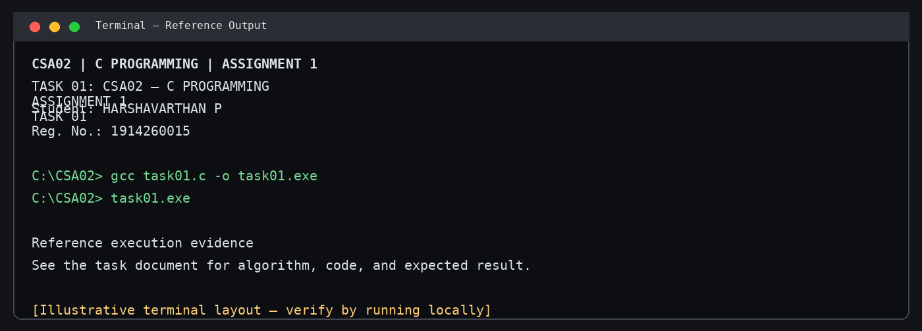
Illustrative terminal-style output screenshot

